Use of interviews, photographs,
video and sound recordings

Thank you for talking to us today, and agreeing to be recorded/filmed/interviewed. The person you’ve been chatting with should have explained what this was for. If you’re unsure – just ask!
Throughout 2024, Church Action on Poverty, as part of the Let’s End Poverty movement, is organising and supporting a series of conversations, under the name Neighbourhood Voices. We know that far too often, we all hear from the same voices over and over again. We know that too many people are ignored and unheard. We always want to change that, but especially in a General Election year, when politicians might listen more to what people want to say.

What’s this form for?
We would like to publish some of the conversations and comments online, on the Let’s End Poverty campaign website and the Church Action on Poverty website. We’d also like the option of sharing the comments with partners, and sometimes with the media. But, we will only do what you’re happy with.

We need to keep a record, so we can check what different people have agreed to. So we ask you to fill in the form attached to this sheet and pass it to the person who chatted with you today.
We know some of this looks very formal, but this form enables us to keep track of things. We ask for your contact details so that if we ever need to check anything, we can contact you. If you ever want to contact us to change, correct or add anything, you can email gavin@church-poverty.org.uk or phone 0161 872 9294.
If you too would like to use any of the photos, videos or notes taken today, please ask the person you have spoken with.
If you ever change your mind about your comments or photos being used, please let us know.
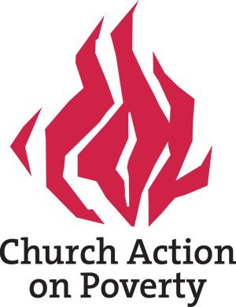
You’ll see that the form refers to Church Action on Poverty. This is the organisation that is holding the photos and this information.

Please tick these boxes if you consent
- I am happy for photographs that include me from today’s event to be used
- I am happy for my comments to be used
- I am happy for my full name / first name to be used (delete as appropriate or leave unticked)

I understand that the information, video and sound recordings may appear in reports, publications, websites, articles, publicity and training leaflets and other materials.
I understand that Church Action on Poverty may distribute this material to the media, both in the UK and internationally, to be broadcast and/or published an unlimited number of times.
I understand that no fee is payable to me by Church Action on Poverty or any other person in respect of use of the information, images and recordings, either now or in the future.
I understand that images, information and recordings may be held on an electronic database by Church Action on Poverty.
I understand that Church Action on Poverty will have copyright on the information, images and recordings but that I will also be able to use them as I wish.
I confirm that the purposes for which information, images and recordings will be used have been explained to me in terms I have understood.
Individual’s name:
(or parent/guardian’s name if the individual is under 18 years of age)

Signature:
(or parent/guardian’s signature if the individual is under 18 years of age)
Date:
Address:
Email address:
Telephone number:

Signed for Church Action on Poverty:
Date:

